A1 – Analyzing the Problem
Humans have been loaning and selling goods for centuries but it has come with complications. Different versions of record keeping for inventory were kept but it was always a painstaking process. As businesses grow, they have to keep track of more inventory and do more than know an item is in stock. An example of some snowboard shop item retail prices follows:
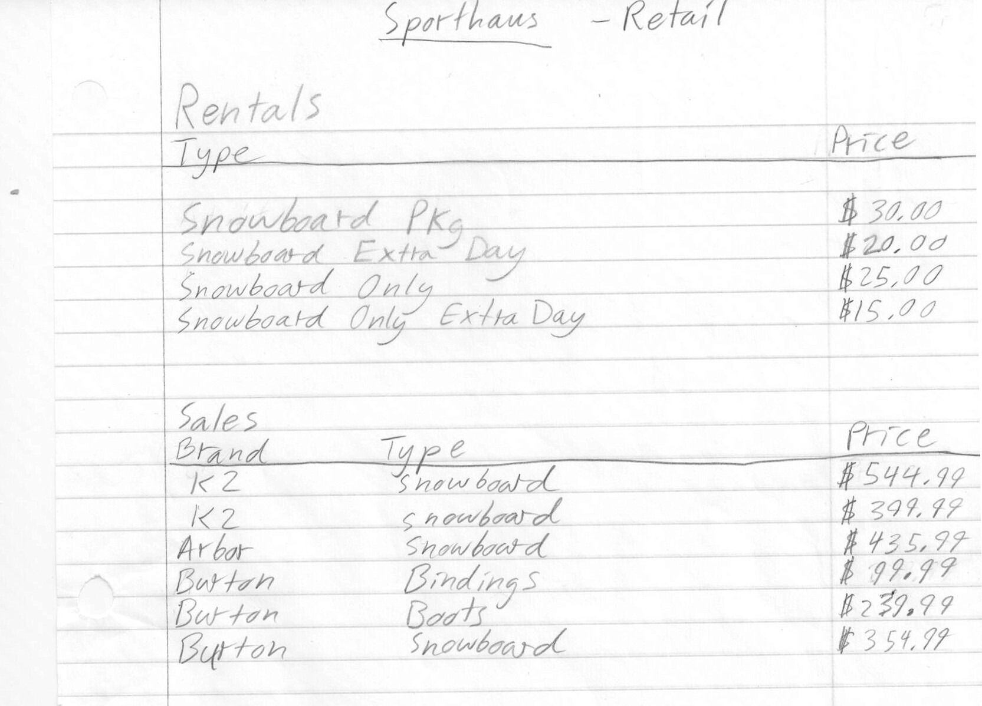
As the part numbers and quantities are important, businesses like Sporthaus cannot release this information.
It is difficult to keep track of all of the items and information in an organized manner. The incoming inventory and outgoing inventory must be continuously monitored. All of the item’s information also needs to be kept track of. All of this is important to keep the business running smoothly.
This is especially true when it comes to shrinkage. Shrinkage is the unaccounted for merchandise. It is important for a company to know exactly where its goods are going and where it might be losing money. Missing merchandise can be tracked by comparing the actual number of items in the store to the number of items that should be there.
When supply levels get low, the store needs to be notified. An improvement on this notification system is actually sending in an automatic order for the item that is low in stock. This can be achieved with computer monitoring rather than tedious, erroneous human-monitoring.
Once a customer buys an item, the item needs to be removed from the inventory. This seems simple but it must also be tracked for a period of time to check for shrink.
Renting adds another dimension to the problem as it does not leave stock unless it is actually broken. It leaves the store but is still considered the business’ property. This means it should still be in the system, but it can’t be counted as available to other customers.
Some companies have tried to solve these problems with programs like Retail STAR which is a point of sales program as well as an inventory system. I plan to concentrate my program on the problem of the inventory system. Simplicity and user-functionality are sometimes lost in large all-encompassing programs, but I think it is very important. The additional user capability will save time when customers need help.

